Student Name 1: Curtis Collins
Student Name 2: Lee-Ong Sim
POD# 05 R# POD# S#
Network Subnet: Network Mask:
Network Subnet: Network Mask:

Topology Diagram

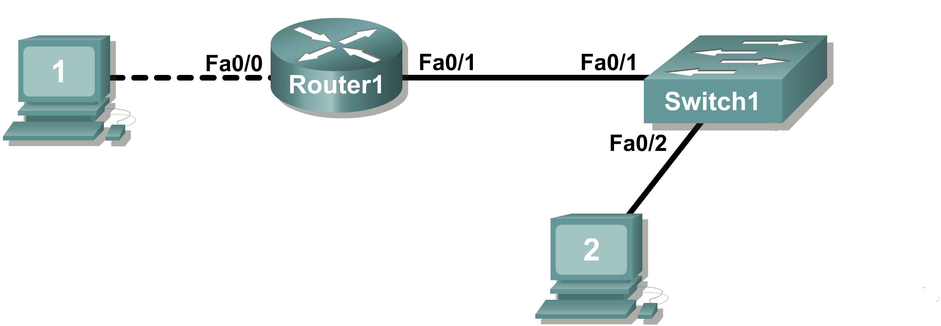

[2 Marks] IP address 198.133.219.0/24, with 4 bits borrowed for subnets
Maximum number of usable subnets: 16

Number of usable hosts per subnet: 14

 | IP Address:198.133.219.0 |  | Subnet mask: 255.255.255.0
# | Subnet | First host address | Last host address | Broadcast
0 | 198.133.219.0 | 198.133.219.1 | 198.133.219.14 | 198.133.219.15
1 | 198.133.219.16 | 198.133.219.17 | 198.133.219.30 | 198.133.219.31
2 | 198.133.219.32 | 198.133.219.33 | 198.133.219.46 | 198.133.219.47
3 | 198.133.219.48 | 198.133.219.49 | 198.133.219.62 | 198.133.219.63
4 | 198.133.219.64 | 198.133.219.65 | 198.133.219.78 | 198.133.219.79
5 | 198.133.219.80 | 198.133.219.81 | 198.133.219.94 | 198.133.219.95
6 | 198.133.219.96 | 198.133.219.97 | 198.133.219.110 | 198.133.219.111
7 | 198.133.219.112 | 198.133.219.113 | 198.133.219.126 | 198.133.219.127
8 | 198.133.219.128 | 198.133.219.129 | 198.133.219.142 | 198.133.219.143
9 | 198.133.219.144 | 198.133.219.145 | 198.133.219.158 | 198.133.219.159
10 | 198.133.219.160 | 198.133.219.161 | 198.133.219.174 | 198.133.219.175
11 | 198.133.219.176 | 198.133.219.177 | 198.133.219.190 | 198.133.219.191
12 | 198.133.219.192 | 198.133.219.193 | 198.133.219.206 | 198.133.219.207
13 | 198.133.219.208 | 198.133.219.209 | 198.133.219.222 | 198.133.219.223
14 | 198.133.219.224 | 198.133.219.225 | 198.133.219.238 | 198.133.219.239
15 | 198.133.219.240 | 198.133.219.241 | 198.133.219.254 | 198.133.219.255

[1 Mark] Logical Topology

Host1
IP Address
IP Mask
Gateway Address
Host2
IP Address
IP Mask
Gateway Address
Router1 Interface Fa0/0
IP Address
IP Mask
Router1 Interface Fa0/1
IP Address
IP Mask

[3 Marks] Connectivity

To be filled in by Lab Instructor

☺ Ping host1 – Fa0/1
☺ Ping host2 – Fa0/0
☺ Ping host1 – host2
☺ Clean up

Lab Instructor _______________________

[7 Marks] Cisco Router Configuration
Copy and paste the Cisco router configuration output

[5 Marks] Cisco Switch Configuration
Copy and paste the Cisco switch configuration output

[2 Marks] Hosts Computer Configuration
Copy and paste the hosts' ipconfig output – for both hosts

